**Ass 4 Handling missing values, Feature Scaling, Inconsistent values in the given dataset.**

**Handling missing values :**

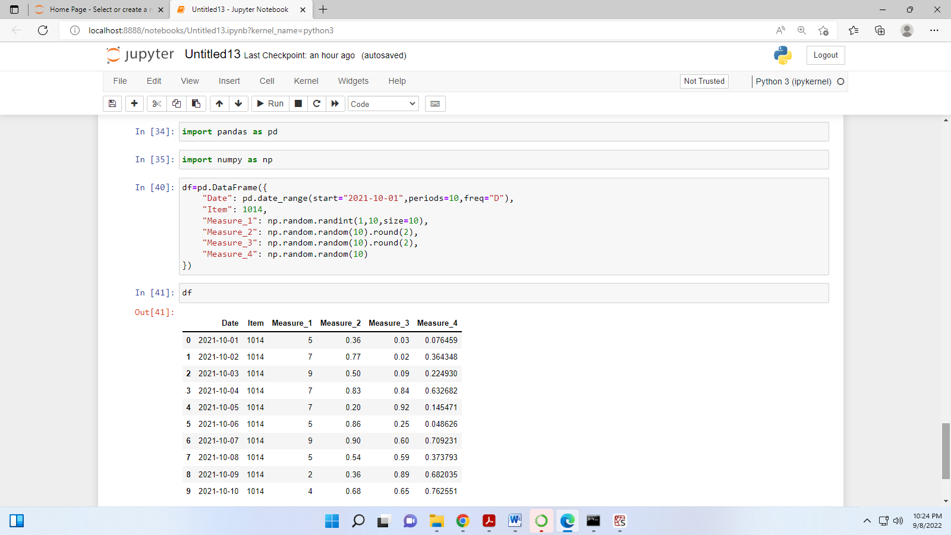

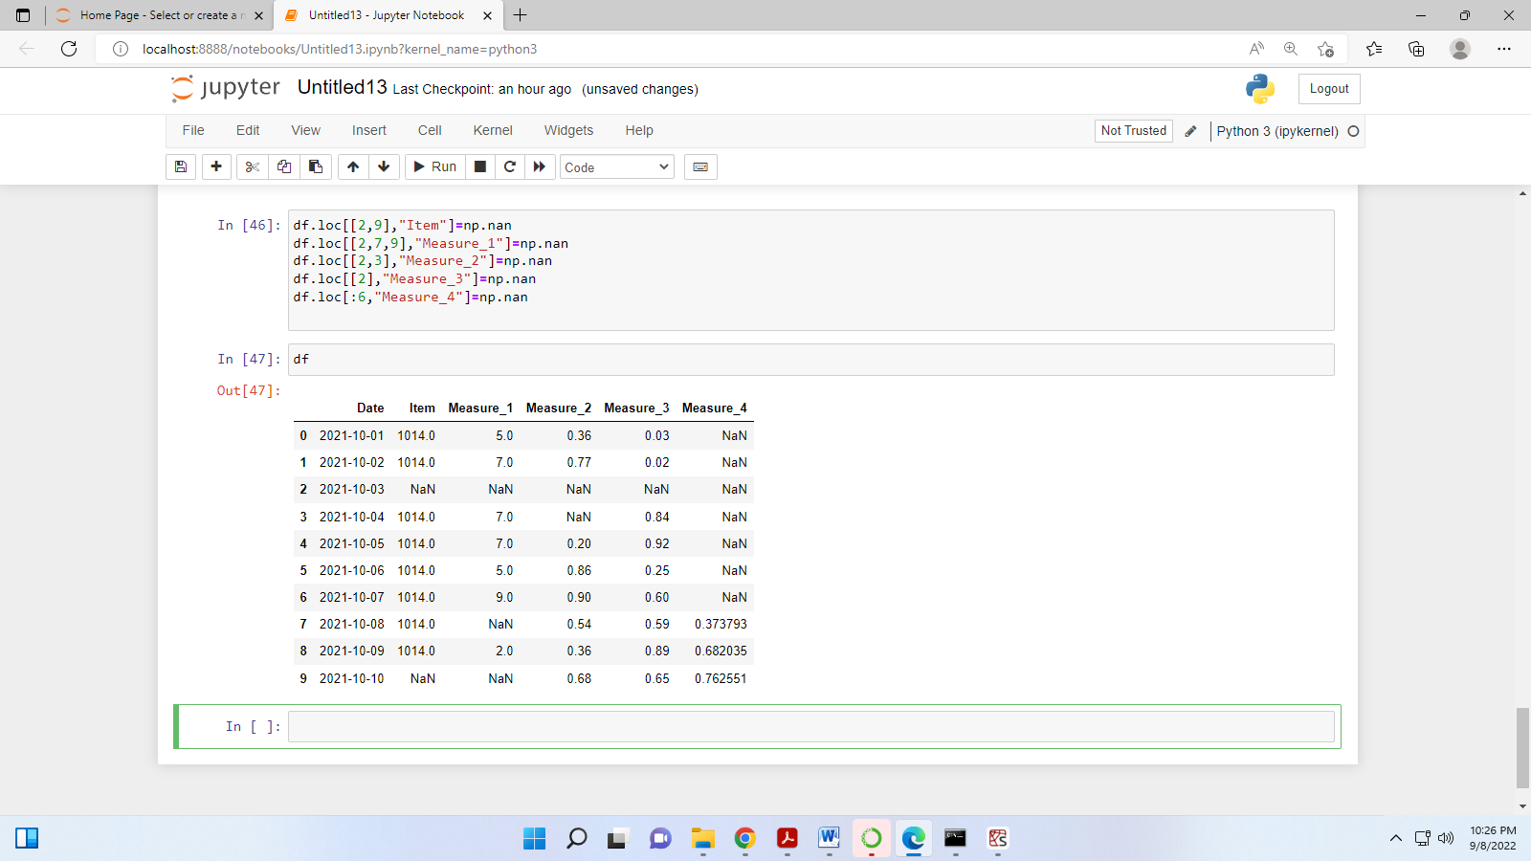

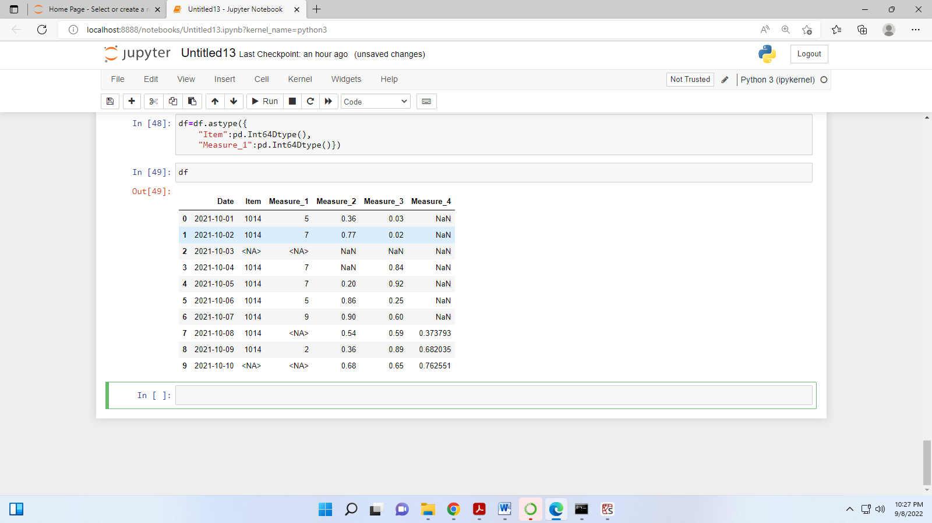

**1. Drop rows or columns that have a missing value**

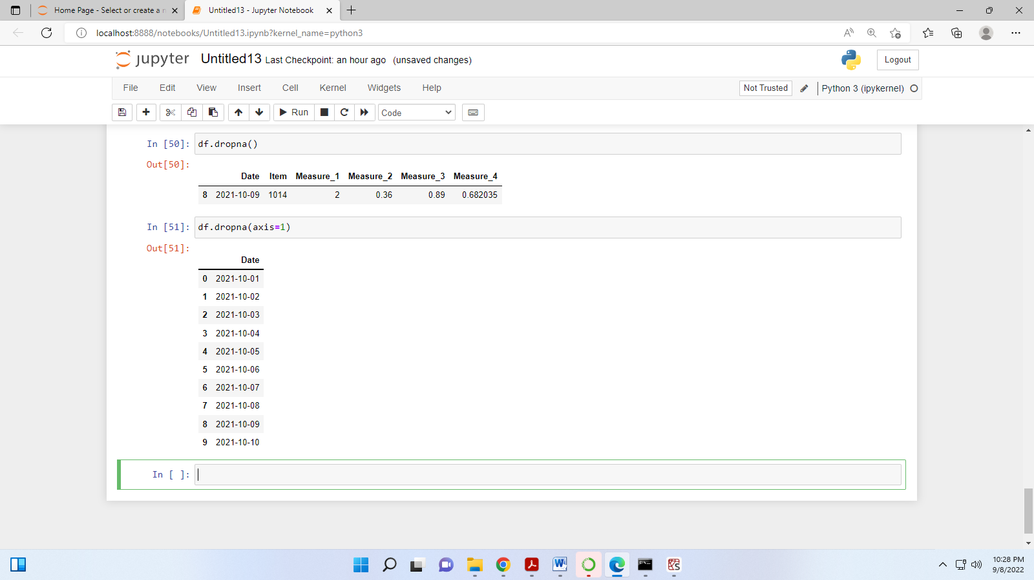

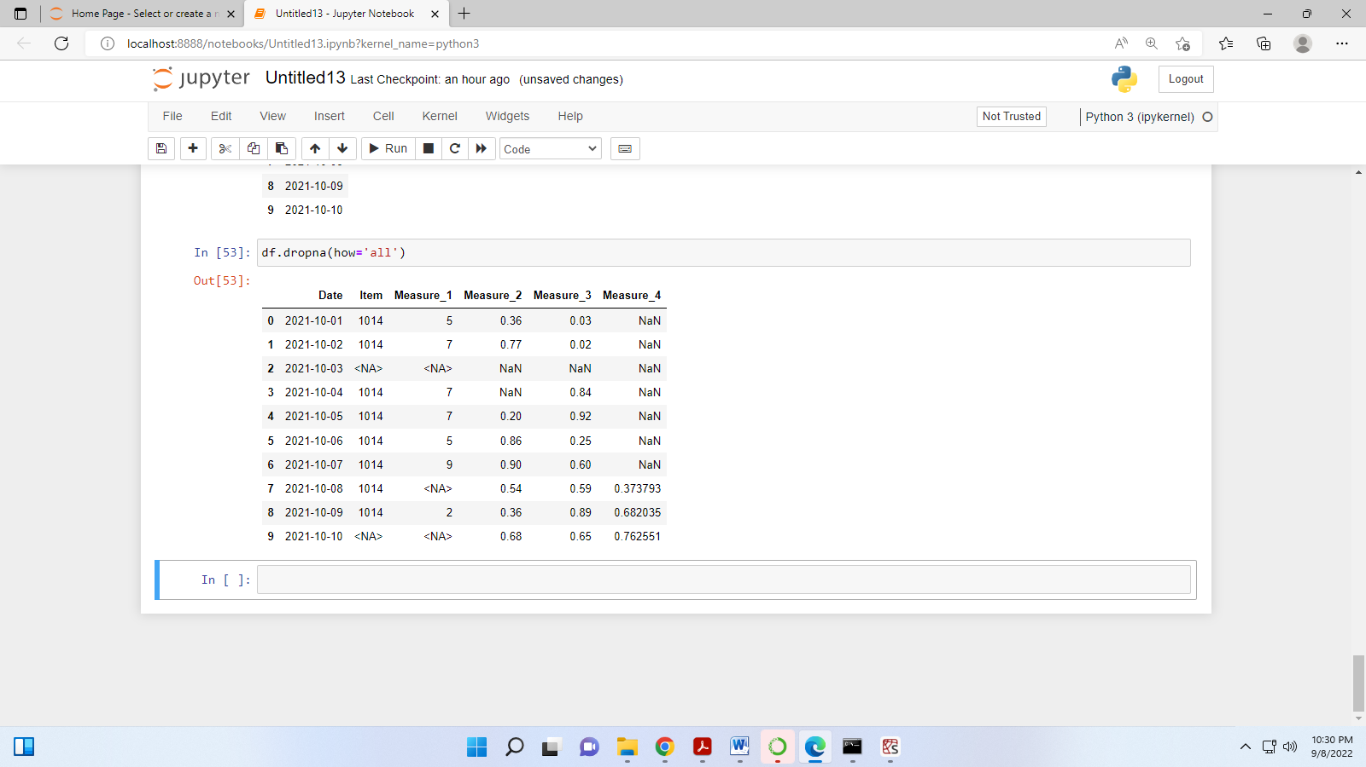

## 2. Drop rows or columns based on a threshold value

For instance, “thresh=4” means that the rows that have at least 4 non-missing values will be kept. The other ones will be dropped. Our data frame has 6 columns so the rows that have 3 or more missing values will be dropped.

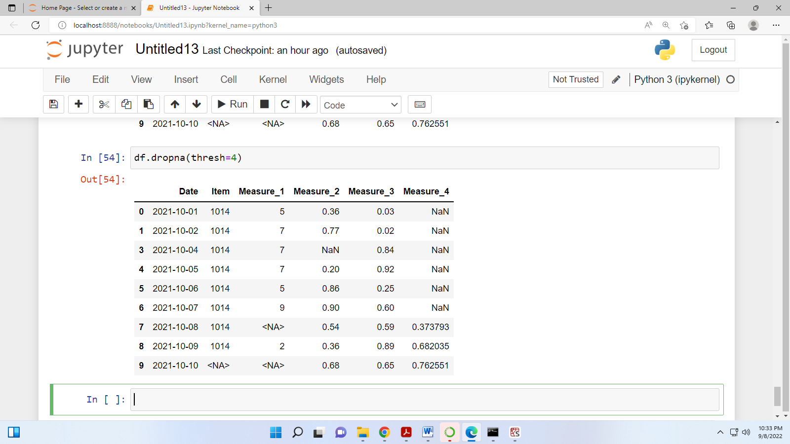

## 3) Drop based on a particular subset of columns:

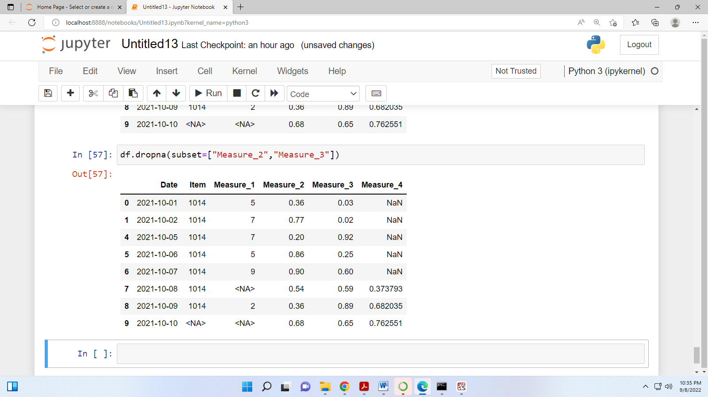

**4) Fill with a constant value :**

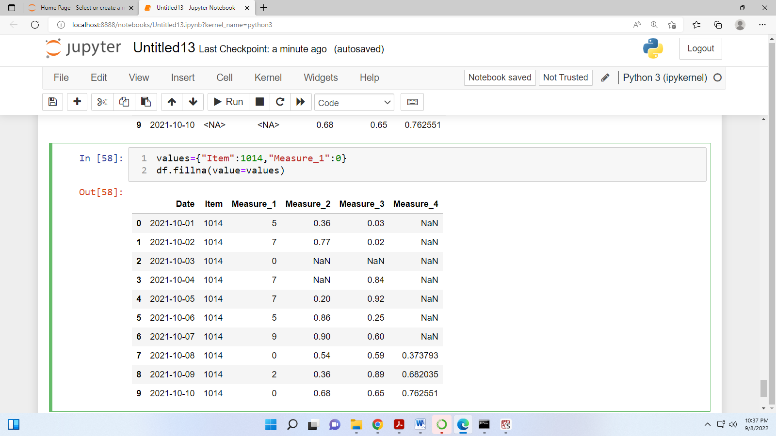

5. Fill with an aggregated value:

